**Results**

The following results section follows fuel cells A, B, and C, with A being the control.

Note that until day 14, there is no difference between A and the other fuel cells.

From the first 4 readings going from 2-26-2017 PM to 2-28-2017 AM (slightly over 36 hours) the readings went from around 5.0mV to 0. Then for the next 5 readings, from 2-28-2017 PM to 3-2-2017 PM(≈47 hours) the readings dropped to -4.2mV. By then it was discovered that the fuel cells were mislabeled, and the ones that were supposed to be negative were labeled positive and visa versa, so the readings were changed accordingly.

For the next 12 readings from 3-2-2017 PM to 3-8-2017 PM(slightly less than 6 days) A (the control) rose up to around 6.8, B rose up to 12.7, and C rose up to 9.9. Then for the next 5 readings from 3-9-2017 PM to 3-12-2017 PM(≈2.75 days) the readings dropped to 5.7 for A(the control), 9.1 for B, and 9.9 for C.

Then on the 14th day of testing, mashed up pineapple, banana, and strawberry were added to C, and approximately the same amount of sugar in the fruit added to C was mixed with water and added to B, but A stayed the same. Then data was collected, and B dropped down to 0.5, C dropped down to 0.3, and A(the control) rose to 6.2.

For the next 2 readings from 3-12-2017 PM to 3-13-2017 AM (≈12 hours) A(the control) dropped to 5.3, B hit 0, and C rose up to 3.4. Then for the next reading from 3-13-2017 AM to 3-13-2017 PM(≈13 hours), A(the control) and C dropped to 0.5 for A, and 0.1 for C, and B stayed at 0.

For the next 3 readings from 3-16-2017 AM to 3-19-2017 PM(≈3.75 days) everything read 0mV. Then it was noticed that the water level in the cathode chamber(the salt water chamber) had dropped significantly, so filtered tap water was added. Then for the next reading at 3-20-2017 AM (≈12 hours after the last reading), A(the control) rose up to 5.4, B stayed 0, and C rose up to 0.1. Then for the reading after that at 3-20-2017 PM (≈13 hours after the last reading), A(the control) dropped to 0.3, B stayed at 0, and C rose up to 4.5. The last reading was taken on 3-21-2017 AM (≈11 hours after the previous reading). A dropped down to 0.2 and C dropped down to 1.9

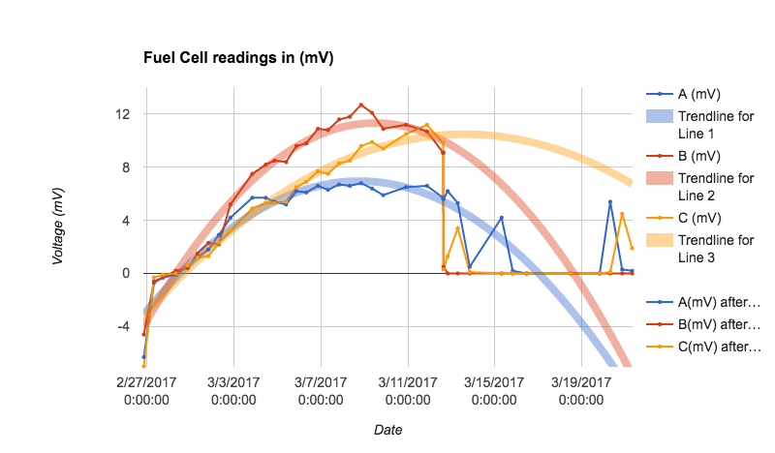

Readings from 2-26-2017 to 3-21-2017 with trendline based off of readings from 2-26-2017 to 3-21-2017(before new fuel was added)

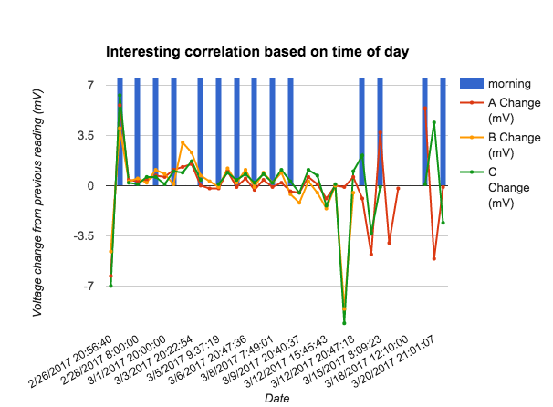

Change in mV for A, B, and C(red, yellow, and green) vs if the reading was taken in the morning